SOME KEY IDEAS FOR A BETTER FUTURE
Here are some sources of ideas that offer food for thought:
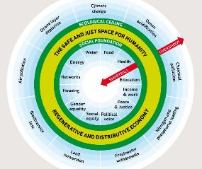
“Doughnut Economics” – the idea that we need a new economics that keeps economic activity between an ecological ceiling and a social foundation floor, below which no one should live in poverty.
- see Kate Raworth’s website and short videos: https://www.kateraworth.com/animations/ (7x one minute)
and her TED lecture: https://www.youtube.com/watch?v=1BHOflzxPjI (17 minutes);
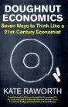
- Johan Rockstrom’s Planetary Limits TED Lecture (18 minutes) https://www.ted.com/talks/johan_rockstrom_let_the_environment_guide_our_development
- Kate Raworth’s book (2017) is accessible to a wider audience.
From Feb. 2018 it has been available in paperback

The Economy for the Common Good – is a vision of a fairer society based on inclusive democratic participation, building an economy that increases the wellbeing of everyone and which protects our environment for future generations. Success would be measured in terms of contributions to the common good rather than profits for shareholders.
- The UK website is https://www.ecguk.org/

- A cartoon (translated from German) (5 minutes) offers an overview of the ideas. Find it on YouTube: https://www.youtube.com/watch?v=r92Cg_iv_GM

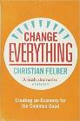
- Christian Felber explains in a TED lecture (23 minutes): http://www.tedxvienna.at/watch/what-if-the-common-good-was-the-goal-of-the-economy-christian-felber-tedxvienna/

- Useful Article in the Guardian by Bruce Watson (2014): ‘Can we create an 'Economy for the Common Good'? https://www.theguardian.com/sustainable-business/values-led-business-morals-economy-common-good

- Christian Felber: Change Everything: Creating an Economy for the Common Good, ZED Books 2015, ISBN 9781783604722 has a full description of the ideas.

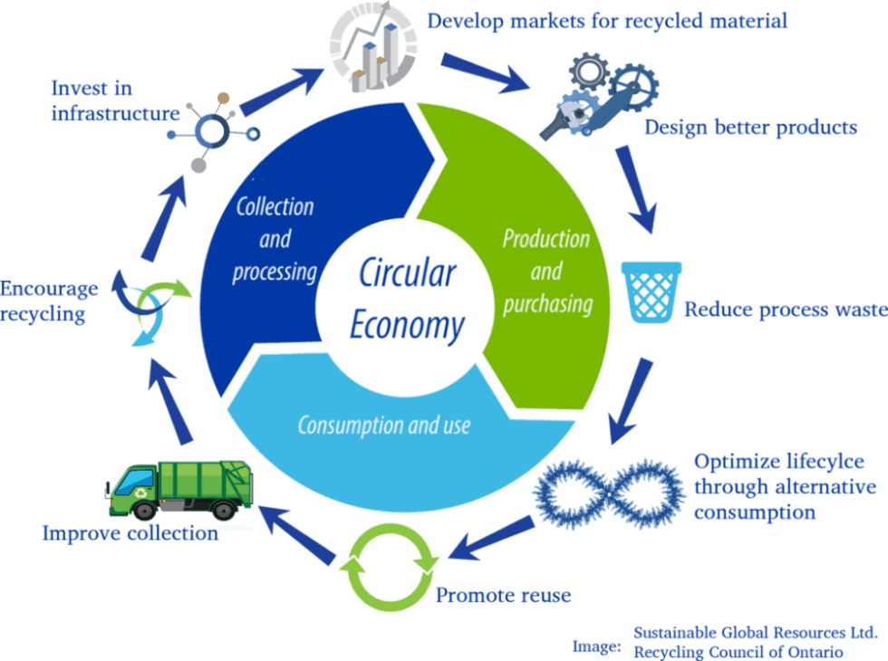
The Circular Economy recognises that our current traditional linear economy, which has a 'take, make, dispose' model of production is extracting resources faster than the planet can regenerate them and creating waste faster that the planet can absorb it.
A circular system reduces the consumption of finite resources by designing waste out of the system by making products to last (through long-lasting design, maintenance, repair, reuse, remanufacturing, and refurbishing, ) then reuses and recycles “waste” materials to make new products. It is based on 3 principles:
- Design out waste and pollution
- Keep products and materials in use
- Regenerate natural systems
This short video (3mins 48 secs.) explains the principles: https://www.youtube.com/watch?v=zCRKvDyyHmI
Proponents of the circular economy suggest that a sustainable world does not mean a drop in the quality of life for consumers and can be achieved without loss of revenue or extra costs for manufacturers. The argument is that circular business models can be as profitable as linear models, allowing us to keep enjoying similar products and services.
Find out more at the Ellen Macarthur Foundation; this video captures the excitement!
Green New Deal
This a really important plan for reshaping our economy to address climate change and social injustices, through investment in green technologies and in consultation with local communities. Watch this short video with Caroline Lucas:
https://www.youtube.com/watch?v=Rdytlt5hYjk&feature=youtu.be. This is one of a series of informative videos being put out by the Green Party.
A version of the Green New Deal is also being discussed in the USA as a grand plan for tackling climate change. A congressional resolution introduced by Democrats, calls on the federal government to wean the United States from fossil fuels and curb planet-warming greenhouse gas emissions across the economy. It also aims to guarantee new high-paying jobs in clean energy industries.
(Source: Lisa Friedman, New York Times, 11 Feb 2019 https://www.nytimes.com/2019/02/21/climate/green-new-deal-questions-answers.html )
Ann Pettifor has written a book ‘The Case for the Green New Deal’ and there are links to lots of relevant articles on her website: https://www.annpettifor.com/topics/green-new-deal/

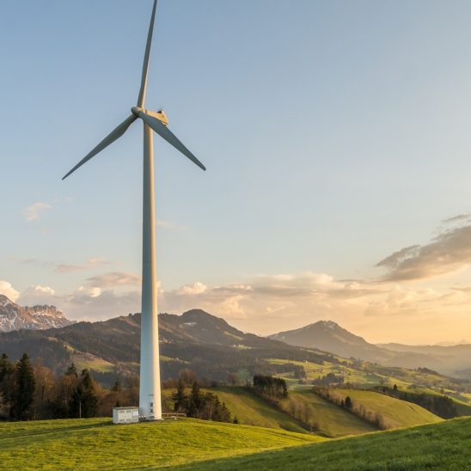
The Centre for Alternative Technology has produced an update of its Zero Carbon Britain report and there’s a useful video (https://www.cat.org.uk/info-resources/zero-carbon-britain/
2 mins) on their website: Zero Carbon Britain - it makes the case that renewable energy could supply all the UK’s needs.

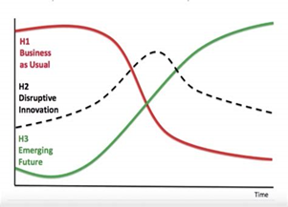
Three Horizons Thinking - This is about futures thinking – it compares the trend we were embarked on before the coronavirus (‘business as usual’) with an alternative economy approach (‘emerging future’). It also includes a ‘disruptive innovation’– which is when something happens to disrupt the existing trend. (The 2020 situation with the Coronavirus is not an invention but it has disrupted ‘business as usual’ – so food for thought here), suggesting questions we should be asking about how to use this opportunity to make the transition towards a new sustainable greener inclusive future.
For a simple graphic explanation, watch this quick introduction by Kate Raworth, Aug 8, 2018.
Three Horizons Framework – (https://www.youtube.com/watch?v=_5KfRQJqpPU 7 minutes) .

And here is a useful way to look at some facts about Change
As we think about change in in the aftermath of the Coronavirus pandemic, we need to be aware of what progress had been made in recent decades to reduce poverty. The International Development Secretary, Anne-Marie Trevelyan, has suggested that the lockdown measures taken to halt the disease will plunge the world economy into recession and undo 30 years of progress in developing countries (Trevelyan in the Guardian 29 April 2020
Hans Rosling has done a great job of collating and animating statistics which offers new insights into the real story behind poverty and development, in an entertaining and informative way.
This article: https://www.theguardian.com/world/commentisfree/2018/apr/11/good-news-at-last-the-world-isnt-as-horrific-as-you-think summarises his view that we need to look at the progress made to reduce poverty to have a balanced view of change. He does not deny that there is more work to do but says we need to be aware of what has been achieved to believe that change is possible and have the hope to carry on. (A physician, as well as an academic and a statistician, he recommends this “factfulness” for our mental health!)

Gapminder Foundation (https://www.gapminder.org/ )
This website Gapminder: Unveiling the beauty of statistics for a fact-based world view. was set up by Hans (who died in 2017) and his family – to enable you to explore the facts about our changing world:
- You can take the Gapminder test ( here ) to see how much you know about how development has changed in the world.
- You can see videos and Ted Talks (about 60 minutes) including Hans’s: “How not to be ignorant about the World”

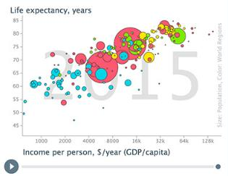
- You can download the film “Don’t Panic — End Poverty” (58 minutes). Hans Rosling asks: Has the UN gone mad?
- You can explore the dynamics of key changes through Hans’s animated graphics
( click here to see the latest chart)
(This is a great resource for teachers)

- “Dollar Street” (here) offers insights, photos of homes around the world, to supplement statistics.

